Mother And Child, by Paul Klee and JDC
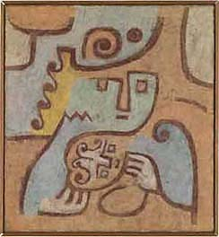
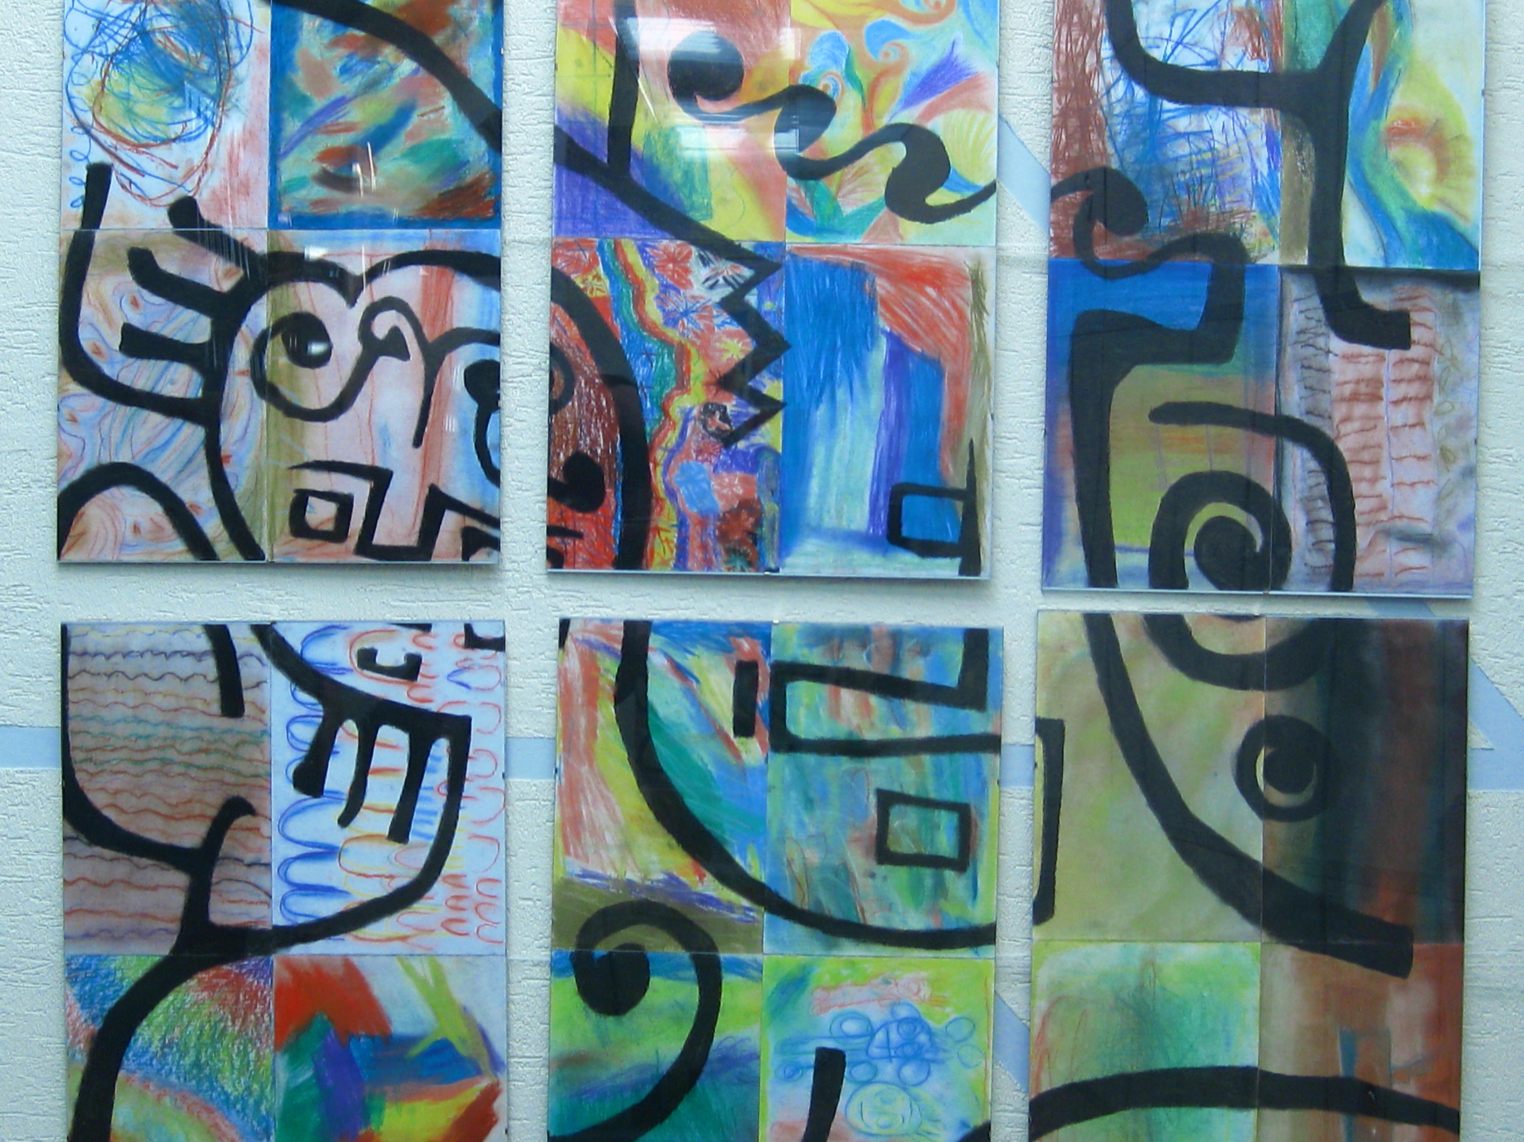

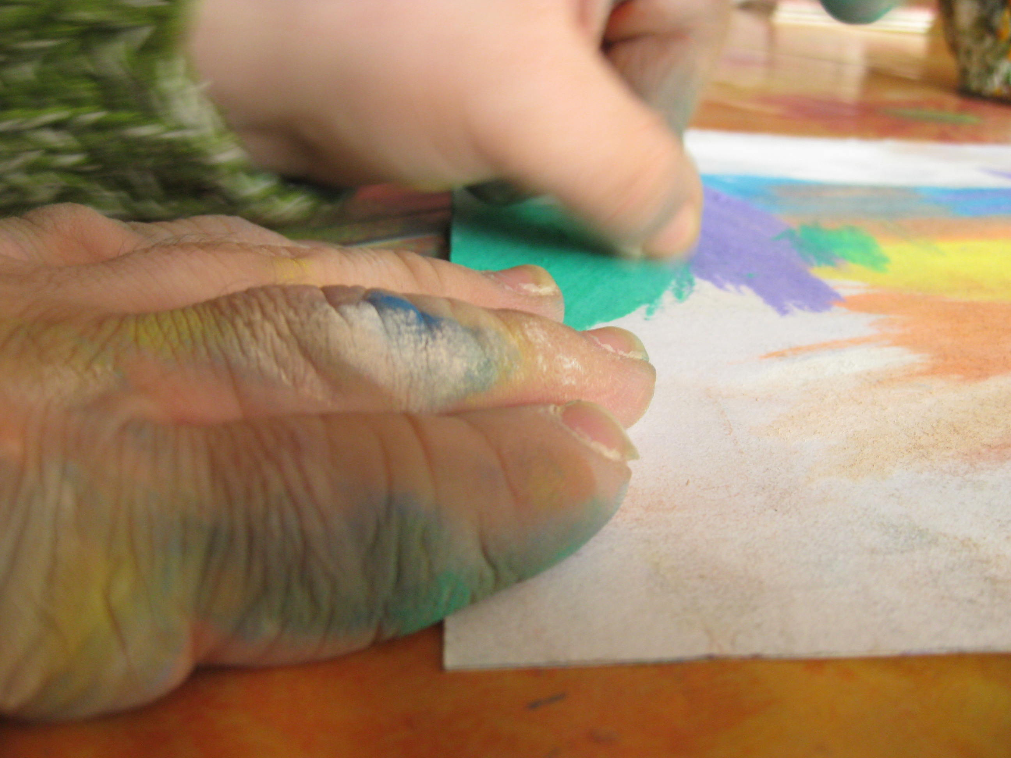
With my project I wanted to combine something of my homecountry with my work mainly in the art course of the JDC. My grandmother was a big help for me because for christmas she sent me a book with illustrations of Paul Klee which gave me the inspiration how to realize the idea I had already some time ago in the beginning of the year.

Paul Klee was a German painter of the beginning of the 20th century. In my eyes his picture “Mother and Child“ shows the feeling of security and is a more concrete drawing than many other pictures by Klee. Two good reasons to choose it.

The next step was to think about how to realise my idea. Finally I decided to let every student draw with pastel chalks on A4 papers. The students should have the opportunity to be creative and to explore a new art technique themselves. For me it was important that the students could be as independent as possible while working. That‘s why now just the lines on the colourfull background which is created by the students and all the workers are reminding the viewer of the orriginal drawing by Paul Klee. For me the picture shows the individuality of everybody but also the being and living together here in JDC.
Savanore Pauline, July 2009

